**UNIT #7 – CIVICS & ECONOMICS – EXTRA PRACTICE (BONUS)**

*You must complete it all and turn in with your file on test day to receive any credit!*

* CALCULATING TAXES:

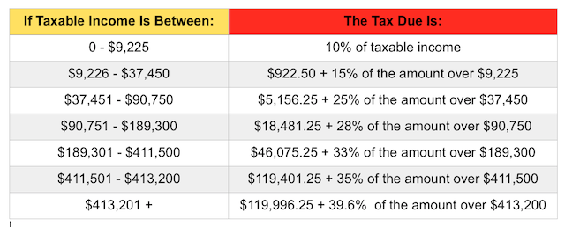

* + Example: Your gross (taxable) income for 2015 was $50,451. You spent $20,000 on housing, food , and other needs. You spent $10,000 on wants, $1,000 on donations/gifts, $2,000 on savings, & $2,000 on investments.
    - Marginal tax rate = _____
    - How much will you owe in taxes?

Taxes = (m__________ tax rate)(g______ i_________ - maximum income of last bracket) + (maximum tax amount from previous bracket)

= (______)($____________ - $____________) + ($____________)

= $____________

* + - What is your effective tax rate?

Effective tax rate = (Taxes Owed)(100%) / (Gross Income)

= ($____________)(100%) / ($___________)

= ________%

* + - What is your disposable income?

Disposable income = Gross income – Taxes owed

= $__________ - $___________

= $___________

* + - What is your discretionary income?

Discretionary income = Disposable income – necessities

= $____________ - $______________

= $____________

* + - What is the balance of your budget?

Balance = Discretionary inc. – wants – donations/gifts – savings – investment contributions

= $____________ - $____________ - $____________ - $____________ - $___________

= $____________

* + - Positive balance (SURPLUS) or negative balance (NEGATIVE)? _________________
    - What percentage of your gross income goes toward wants?

% Wants = ($ Wants)(100%) / ($ gross income)

= ($__________)(100%) / ($____________)

**SEE THE BACK FOR WRITING A CHECK & BALANCING ACCOUNTS 🡪**

**KEEPING TRACK OF DEPOSITS, WITHDRAWLS, & TRANSFERS:**

*Use scenario to complete the account balances below and find ending balances on your checking & savings accounts:*

(1) You have a checking account with a balance of $3,000 at the beginning of the month and savings account with a $5,000 balance at the beginning of the month.

(2) You pay RENT by writing a check for $700.

(3) You pay UTILITIES by automatic bill pay for $200.

(4) You buy GROCERIES for the month for $200 using your debit card.

(5) You buy GAS for $100 with your debit card.

(6) You TRANSFER $400 from your checking account into your savings account.

(7) You are paid at the end of the month through direct deposit for $3,000 into your checking account. (PAYCHECK)

(8) You earn 1% INTEREST EARNED off of the ***beginning balance*** on your savings account.

|  |  |  |  |
| --- | --- | --- | --- |
| **CHECKING** | | | |
|  | **DEPOSITS** | **WITHDRAWS** | **BALANCE** |
| **BEGINNING OF MONTH BALANCE** |  |  |  |
|  |  |  |  |
|  |  |  |  |
|  |  |  |  |
|  |  |  |  |
|  |  |  |  |
|  |  |  |  |
|  |  |  |  |
|  |  |  |  |
| **END OF MONTH BALANCE** |  |  |  |

|  |  |  |  |
| --- | --- | --- | --- |
| **SAVINGS** | | | |
|  | **DEPOSITS** | **WITHDRAWS** | **BALANCE** |
| **BEGINNING OF MONTH BALANCE** |  |  |  |
|  |  |  |  |
|  |  |  |  |
|  |  |  |  |
| **END OF MONTH BALANCE** |  |  |  |

WRITING A CHECK

*Write a check, given the following information:*

* Date: June 1, 2016
* Amount: $534.21
* Dollars (write out in words): Five-hundred & thirty-four dollars & 21/100
* Pay to the order of (to whom the money goes): Strickland Propane
* For (reason): Propane
* Signature on bottom blank line (**USE NAME OF CHECKING ACCOUNTS OWNER IN TOP LEFT CORNER**)

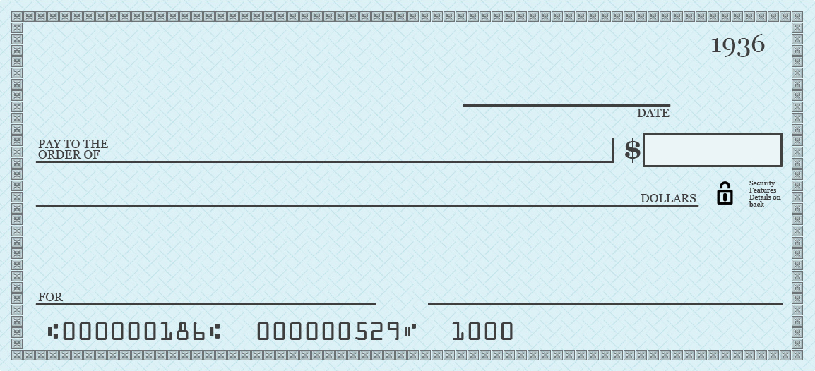

**HANK HILL**

**123 RAINEY STREET**

**ARLEN, TX 54321**