UNIT #8 – CIVICS & ECONOMICS – STUDY GUIDE
CREDIT
(1) The ability to pay someone later is known as c________.
(2) The actual amount of money borrowed is called the p______________.
(3) The amount of money that borrowers need to pay back to the lender is called the i_____________.
(4) When borrowing money or using credit, it is important to pay both the p____________ & i______________.
(5) Items purchased on credit usually end up costing _______ because of i____________ payments.
(6) Consumers should include i____________ & f______ in the final cost of a purchase with credit cards.
(7) If you only pay the minimum balance or interest payments on a credit card, you will ultimately pay _______ than if you paid the entire balance.
(8) Credit scores are based on our ability to pay money that we have borrowed – including the use of c________ c______.
(9) The responsible way to use credit cards is to pay the bill ____ _______, not just the m____________ payment.
(10) Your credit score can go down if you do not pay your bills ____ ______.
(11) By paying bills on time, you can establish a good c________ r__________, making it easier to get a ______ from the bank.
(12) Consumers often use credit or debit cards because it is more c_________________ than paying with cash.
(13) When taking out a loan at a bank, individuals often have to provide c________________, or property that can be taken if they do not make payments on the loan.
(14) Having a bad credit score can lower your ability to get a j____ (employers look at credit ratings/scores), to take out a l______ from the bank (for a mortgage on a house), and sign a service c____________ with a phone carrier (you may have to put down a high security deposit).
SAVINGS/INVESTMENTS
(15) Immediate gratification is when individuals focus on s______-t______ wants over l_____-t______ goals, such as making impulse purchases with money they would have saved for a vacation.
(16) __________________ interest builds upon the entire account balance or both the deposit and previous interest.
(17) __________________ interest builds upon only the principal amount.
(18) __________________ interest grows faster than _________________ interest.
(19) To build more wealth it is better you save (earlier/later) with (compound/simple) interest.
(20) People save money in order to have back-up funds for e__________________, for r_______________, and for m_______ purchases like houses or cars.
(21) ____________ accounts allow us to store our money to access when needed.
(22) ____________ accounts give us easy access to our money with checks and d_____ cards.
(23) _____________________________________ accounts usually earn higher i__________ than regular savings accounts, but require you to have a high minimum balance.
(24) _____________________________________ accounts (CDs) usually earn higher i_____________ than regular savings accounts but require you to hold the deposit for a certain amount of time, usually a _____ or longer.
(25) The ____________________________________________________ insures your money in the bank up a certain amount.
(26) S________ and c_______________ b_______ are riskier than s__________ accounts, U.S. Treasury bills (savings bonds), and CDs because businesses can f_______ and your entire investment could be wiped out.
CONSUMER PROTECTION
(27) The federal government has established several c_______________ protections, such as the National Do Not Call Registry (protects you from unsolicited calls from telemarketers), dietary guidelines (nutrition information and ingredients on packaging), and the Equal Credit Opportunity Act (bans discrimination in getting credit or loans).
(28) What is the organization that a consumer could seek assistance with customer satisfaction ratings of businesses or to see complaints against a business? __________________________________________________________________ (_____)
(29) What is the govt agency that recalls products that are unsafe? ________________________________________________
(30) What is the govt agency that helps investors who have been conned by phony investment schemes?
_____________________________________________________________________________________ (SEC)
BUDGETING
(31) __________________________ income: amount of money you make before taxes or expenses
(32) __________________________ income: amount of money you make after taxes are deducted, but before expenses
(32) __________________________ income: amount of money you have remaining after taxes and expenses for necessities
(33) Three ways to analyze your budget: compare types of expenses as a p________________ of total expenses, compare expenses o______ t______, determine if you need more i_______________ or to cut e______________
(34) ________________: Income minus expenses
(35) ________________: Income > expenses
(36) ________________: Expenses > income
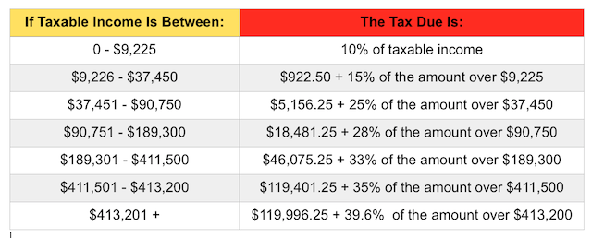BUDGETING
  - Example: Your gross (taxable) income for 2015 was $29,225. You spent $18,000 on housing, food, & other needs. You spent $6,000 on wants, $500 on gifts, $1,000 on savings, & $500 on investments.
    - Marginal tax rate = _____%
    - Taxes =
(0.____)($________ - $________) + ($__________)
= $____________
    - Effective tax rate = ($____________)(100%) / ($___________) = ________%
    - Disposable income = $__________ - $___________ = $___________
    - Discretionary income = $____________ - $______________ = $____________
    - Balance = $___________ - $___________ - $___________ - $___________ - $__________ = $____________
    - Positive balance (SURPLUS) or negative balance (NEGATIVE)? _________________
    - % Wants = ($ Wants)(100%) / ($ gross income) = ($__________)(100%) / ($____________) = _______%
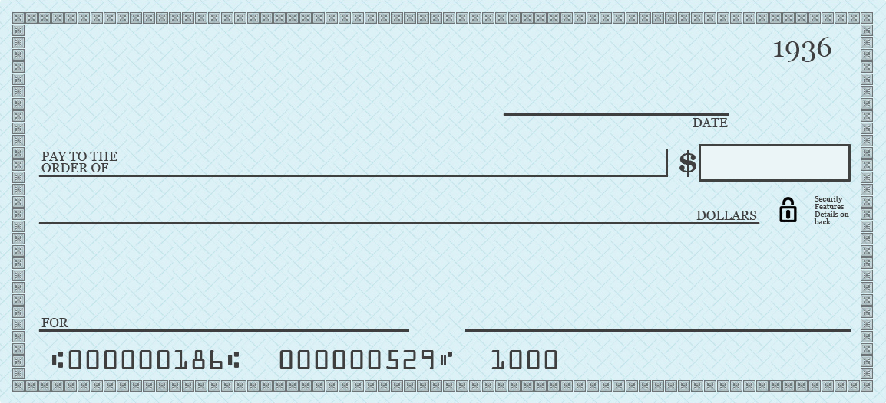
WRITING A CHECK
Write a check, given the following information:
HANK HILL
123 RAINEY STREET
ARLEN, TX 54321

- Date: May 1, 2016
- Amount: $98.76
- Pay to the order of: Mega-Lo-Mart
- For: Lawn equipment

TRACKING DEPOSITS, WITHDRAWS, & TRANSFERS:
Use scenario to complete the account balances below and find ending balances on your checking & savings accounts:
(1) You have a checking account with a $1,500 balance & a savings account with a $5,000 balance at the start of the month.
(2) You pay RENT by writing a check for $500.
(3) You pay UTILITIES by automatic bill pay for $100.
(4) You buy GROCERIES for the month for $200 using your debit card.
(5) You buy GAS for $100 with your debit card.
(6) You TRANSFER $200 from your checking account into your savings account.
(7) You are paid at the end of the month through direct deposit for $3,000 into your checking account. (PAYCHECK)
(8) You earn 1% INTEREST EARNED off of the beginning balance on your savings account.
CHECKING
 | DEPOSITS | WITHDRAWS | BALANCE
BEGINNING OF MONTH BALANCE
END OF MONTH BALANCE

SAVINGS
 | DEPOSITS | WITHDRAWS | BALANCE
BEGINNING OF MONTH BALANCE
END OF MONTH BALANCE

